Travelling into Yesteryear

For the last one thousand years we have been referred to as the Wandering Jew by the nations around us. Although intended as an insult, the truth is we have been fugitives, immigrants, merchants, scholars but above all travellers, ever since we arrived in Europe.

Every country in Europe from Finland to Bosnia has been home to a Kehilla of Jews and to Rabbonim of note (R’ Naftoli Amsterdam and the Chacham Zvi respectively). It is here that Rashi was written, that the Maharal lived and that the Rothschilds ran a banking empire. The birthplace of Ashkenaz and of Chassidus, of the printing press and of Yiddish. It was also where the Crusades and Tach V’Tat were carried out and where Christianity, its ghettoes and its censorship ruled over the Jews.

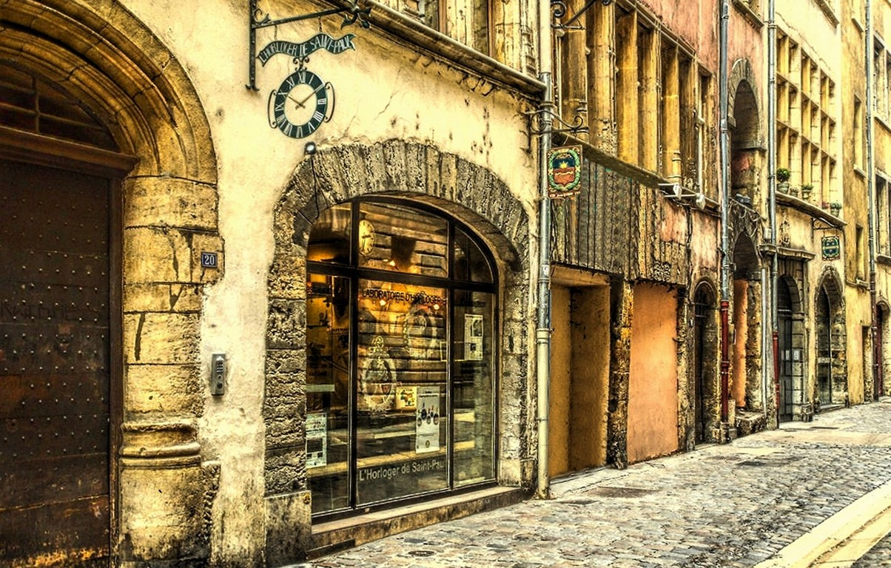
Rue de Juiverie - France

Countless Teshuvos were written to travellers or to those forced into wandering. The Mahrashdam in 16th century Greece was asked whether money could be sewn into clothing and worn on Shabbos - a situation he was mattir. Whereas the Chavos Yair was confronted with a question of minhagim after the city of Worms was destroyed through war and people despaired of it ever being rebuilt. He responded that a community never despairs and indeed he became the Rov there in 1699.

Additionally throughout the ages, famous personalities such as the Chida, Ibn Ezra and R’ Ovadiah Mi’Bartenura travelled widely and wrote diaries to record their impressions. Similarly, Sir Moses Montefiore, who never lost his passion for travel to encounter his fellow Jews or intercede on their behalf, undertook a voyage to Romania in 1867 at the age of 82. Over a 40 year period he would meet the Sultan of Turkey, Nicholas I of Russia and Napoleon III.

European Jewry grew substantially both in numbers and importance from the 11th century onwards. Fewer than 100,000 lived there when Rashi was born in 1040, whereas by 1940, it was home to eleven million – 2/3 of world Jewry.

Visiting these countries is an opportunity to learn how Jews shaped their own history; to see, to touch the memories of communities. They made their mark on the continent and wherever they lived there are traces, although unfortunately traces are often all that’s left. Nonetheless there are a number of hidden jewels such as Provencal France, Sopron in Hungary and Trakai in Lithuania. Even London and Paris have their medieval treasures.

And the further east we go, the more time has almost stopped, and a sense of history permeates everything. So that despite the sensation of tragedy in the air, we are almost able to see how our ancestors lived. To visit Shtetlech, some graced with large and ornate synagogues, others with tiny prayers rooms. Unfortunately many languish in a state of semi-decay although there are endeavours to restore a significant number of them. Occasionally these villages will still be home to a few remaining Jews, who’s stories span not only the Holocaust but 40 years of communism. Their cemeteries are often the resting places of tzadikim but sometimes the location of mass graves - either requiring a perek of tehillim.

The East also occasionally attests to those places have managed the impossible – cities like Odessa which have emerged from an almost total spiritual and physical destruction to forge a future.

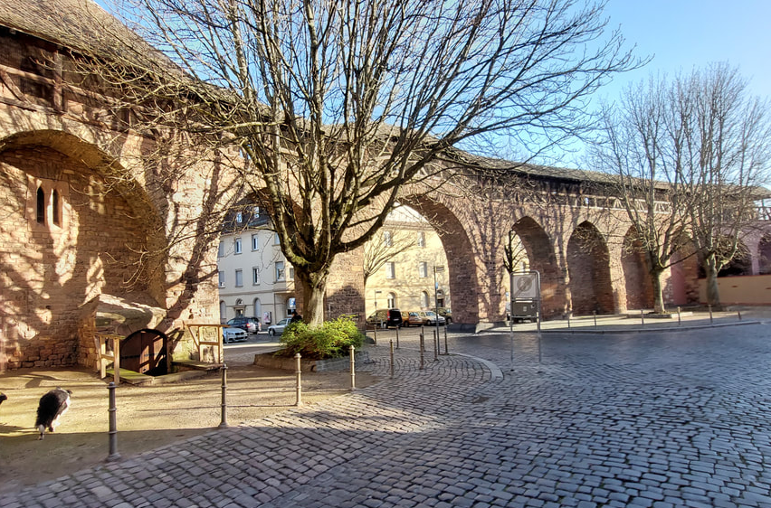
The entrance to the Judengasse - Worms

Poland itself, although initially a place of refuge, was for centuries the location of a form of Jewish self-government through the Va’ad Arba Araotzos and of so much of our collective past. For some there is no longer such place on the map as Poland, it is a country never to go back to. For others, it will give expression to much of what they have been brought up with and heard about. However, it is not just Eastern Europe, where the past speaks to us so strongly, the West has its own stories and legends. The “Austritt” section of the Frankfurt cemetery, separated by a wall from the rest, is physical testimony to the results of the decisions of history. How many descendants of the other section can even claim to be Jewish today?

Naturally for every traveller there will be the town that holds a special place be it Vilna, Uman or Venice. A word of warning though: geographical research may well be necessary. Because the towns we are familiar with, often have a number of different names. People may know that Reisha in

Yiddish is Rszezow (Zse-Zshuv) or that Nowy-Sacz is Sanz, but few realise that Breslau is now called Wroclaw, that Chelm is actually pronounced Che’um and that neither Wisznice or Vishnevets correspond to Vizhnitz. And with borders having moved so frequently, it is unsurprising that Lemberg, which had the largest Jewish community in pre-war Galicia, is not only no longer in Poland but is now called Lviv.

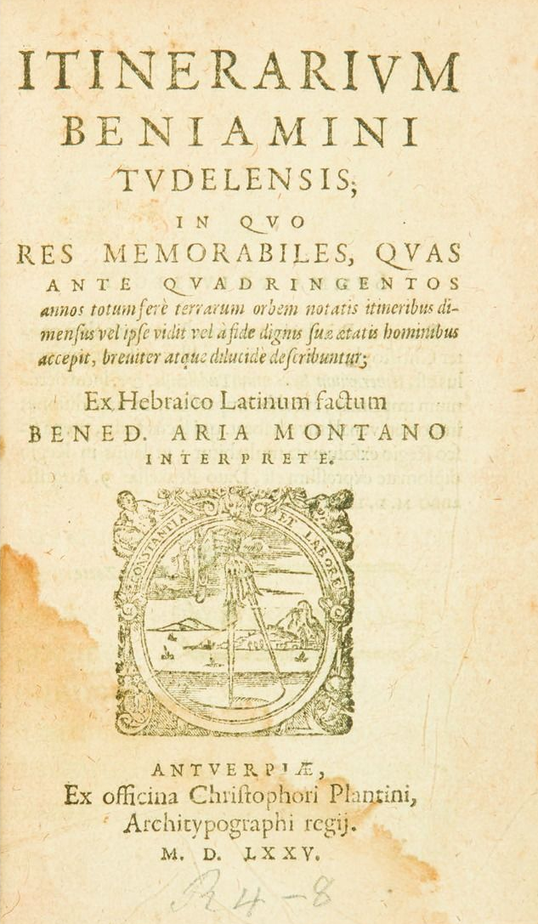
12th century diary of a famous Jewish traveller
It has been said that the world is a book and those who do not travel read only one page, yet the real reason to go is so that you can return with a broader perspective. More informed, more connected and more amazed by the miracle of our survival and by their commitment.

This article originally appeared in Hamodia

